4.3 Maximum & Minimum Values

In the following sections we will begin to investigate how we can use derivatives to determine how various functions behave. In this section we are interested in determining where a function has its largest and smallest values. We define the following terms.

Definition: Suppose that c is a number in the domain D of a function f.
- We say that is an absolute maximum value of f on D if for all x in D.
- We say that is an absolute minimum value of f on D if for all x in D.
- We say that is a local maximum value of f on D if when x is near c.
- We say that is a local minimum value of f on D if when x is near c.

Note: The precise meaning of the word “near” is that the inequality is true on some open interval containing c.

Example 1: Identify where the graph below has local minimum and maximum values.
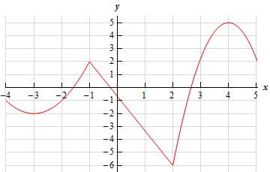

Example 2: Identify the absolute max/min values of the following functions.

- (which is pictured below)
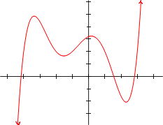

Questions: TRUE or FALSE
- A function can have two absolute maximum values.

- A function’s absolute maximum can equal its absolute minimum.

Example 3: Consider the function pictured below.


- Determine .

- Determine .

Theorem (Fermat’s Theorem): If f has a local minimum or maximum value at c, and if exists then .

Proof: See section 4.3 of the textbook.

Note: Geometrically, Fermat’s Theorem implies that there is a horizontal tangent at points corresponding to local max/min values on a graph (when the function is differentiable).
Example 4: Consider the function .

- Find the value(s) of x that make the first derivative of f equal to 0.

- Is there a local min. or local max. of f at any of the values you found in part (a)?

- TRUE or FALSE: If g is a function and , then g must have a local min or local max at c.

Fermat’s Theorem readily implies the following fact.

Fact: If f has a local maximum or minimum at c, then c is in the domain of f and either or does not exist.

Definition: A critical number of a function is a number c in the domain of such that either or does not exist.

Note: The fact and definition above immediately imply that if f has a local max or min at c, then c is a critical number of f.

Example 5: Find the critical numbers of .

Example 6: Find all the critical numbers of .

Question to the Class: Is it possible to draw a picture of a graph of a continuous function on the closed interval which does not have an absolute maximum value or does not have an absolute minimum value?

The next theorem makes the idea discussed above precise.

Theorem (The Extreme Value Theorem):
If f is continuous on a closed interval , then f attains an absolute maximum valueand an absolute minimum valueat some numbers c and d in .

Note: The extreme value theorem only tells us that absolute max/min values exist. It does not tell us how to find the values. The next procedure we go over will tell us how to actually find the absolute max/min values.

Question: Why would the extreme value theorem not hold on an open interval?

Question: Why would the extreme value theorem not hold if our function was not continuous?
The Closed Interval Method:
This method finds the absolute max/min values of a continuous function on .
- Identify the critical points of f and the endpoints of the interval .
- Find the values of f at these values.
- The largest y-value from step 2 is the absolute maximum value; the smallest of these values is the absolute minimum value.

Note: For the closed interval method to work, we also have to be able to find the derivative of the function f.

Example 7: Find the absolute extrema of on the interval .

Example 8: Find the absolute extrema of on the interval .

Example 9: Find the exact absolute extrema of the function on the interval .

